**ATLAS JUNIOR SCHOOL – LUGOBA NABWERU**



**MID TERM TWO EXAMINATION 2024**

INTEGRATED SCIENCE

***PRIMARY SIX***

***Time allowed: 2 hours 15 Minutes***

Name: ………………………………………………………………………………Stream: …………………….…………

|  |
| --- |
| **FOR EXAMINER’S USE ONLY** |
|  |

|  |  |  |
| --- | --- | --- |
| **FOR EXAMINER’S USE ONLY** | | |
| ***Qn. No.*** | ***MARKS*** | ***EXR’S NO.*** |
| **1-14** |  |  |
| **15-25** |  |  |
| **26 - 39** |  |  |
| **40 - 43** |  |  |
| **44 - 46** |  |  |
|  |  |  |
|  |  |  |
| **TOTAL** |  |  |

**DO NOT OPEN THIS BOOKLET UNLESS YOU ARE TOLD TO DO SO**

**Read the following instructions carefully.**

1. *This paper has two sections:* ***A*** *and* ***B***
2. *Section* ***A*** *has* ***40*** *questions (40 marks)*
3. *Section* ***B*** *has* ***15*** *questions (60marks)*
4. *Answer* ***all*** *questions. All answers to both sections* ***A*** *and* ***B*** *must be written in spaces provided.*
5. *All answers must be clearly written using* ***blue*** *or* ***black*** *ball point pen or ink.*
6. *Unnecessary changes of work may lead to loss of marks.*
7. *Any handwriting that cannot be easily read, may lead to loss of marks.*
8. *Do* ***not*** *fill anything in the boxes indicated. For official use only.*

**SECTION A (40 MARKS)**

1. Name type of blood vessels that transport blood towards the heart.

________________________________________________________________

1. How are splints useful in administering first aid for fractures?

________________________________________________________________

1. Why is a mushroom not grouped under spore producing plant yet it produces by means of spores?

________________________________________________________________

1. Identify the mineral salt that helps in formation of blood.

________________________________________________________________

Below is a diagram of a non flowering plant. Use it to answer question 5 and 6.

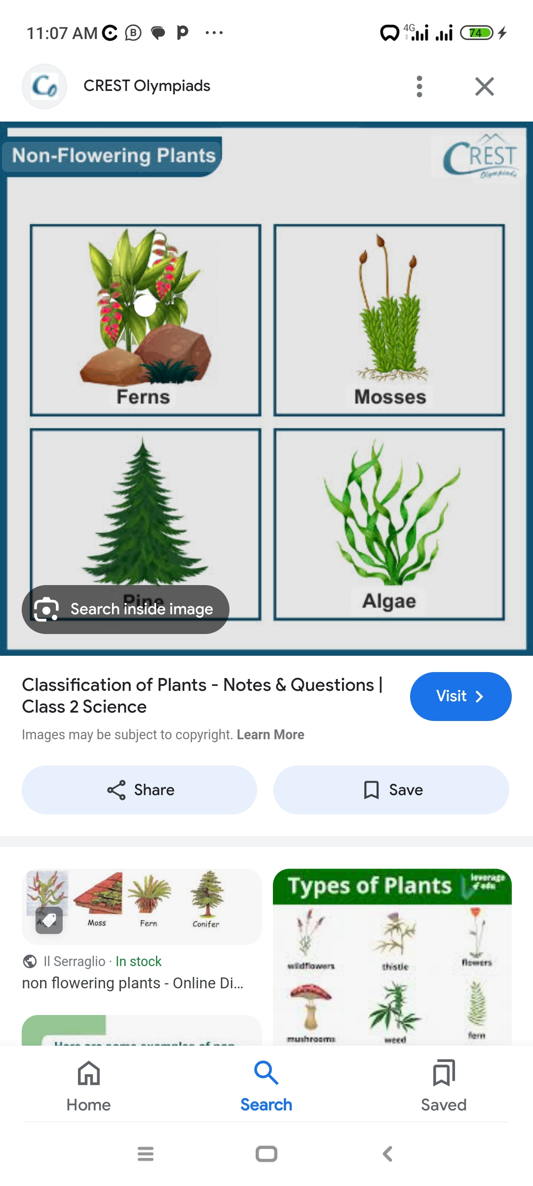

X

1. Name the part marked with letter X.

________________________________________________________________

1. How is part marked X important to the above non- flowering plant.

________________________________________________________________

1. Name the weather instrument used to measure humidity in an area.

________________________________________________________________

1. Give **one** way in which bush burning leads to soil erosion.

________________________________________________________________

1. State the structural difference by dairy cattle and beef cattle.

________________________________________________________________________________________________________________________________

1. State the function of kidneys in the human body.

_______________________________________________________________

1. How does a pawpaw plant protect itself from self pollination?

_______________________________________________________________

1. Name **one** raw material for photosynthesis.

_______________________________________________________________

1. Why are geckos able to walk upside down on ceilings without falling?

________________________________________________________________

1. Give **one** way of avoiding burns while lifting hot object.

________________________________________________________________

Below is a method of vegetative plant propagation. Use it to answer questions that follow.

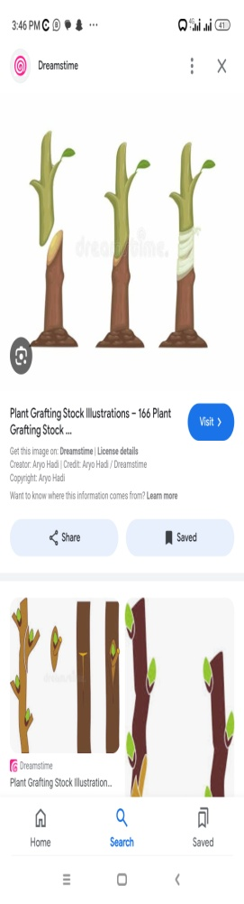

scion

1. Name the method of vegetative propagation shown in the above method.

________________________________________________________________

1. Name **one** plant propagated using the above methods.

________________________________________________________________

1. Which type of feathers help birds to fly?

________________________________________________________________

1. How does a millipede protect itself?

________________________________________________________________

1. Musa usually smokes opium on daily basis, state one effect of smoking opium on Musa’s health.

_______________________________________________________________

Below is method of seed dispersal. Use it to answer questions that follow.

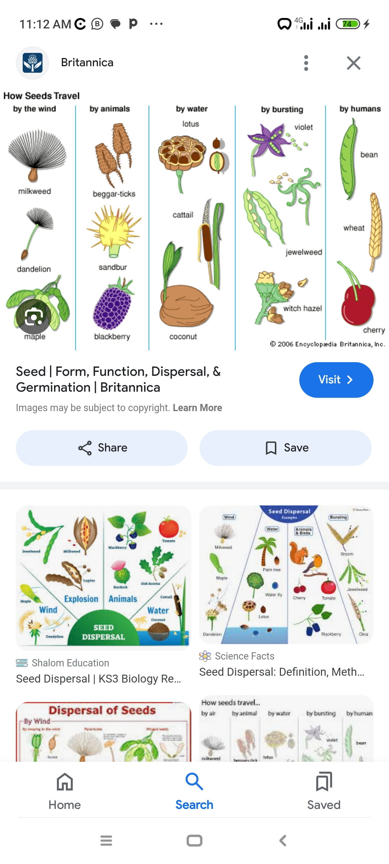

1. How is the seed in the above diagram dispersed?

______________________________________________________________

1. How is the above seed adapted to its mode of dispersal?

_______________________________________________________________

1. Name **one** component of soil.

______________________________________________________________

1. Why do some objects weigh less in water than in air?

_____________________________________________________________

1. In which way is a child health card important to a parent?

_______________________________________________________________

1. Name the immunisable whose sign is stiff muscles and spasm when touched.

________________________________________________________________

1. State **one** factor considered by a doctor when prescribing a drug for a patient.

_______________________________________________________________

1. In which way is a fern plant similar to a maize plant?

_______________________________________________________________

Below is method of brooding chicken, use it to answer question 28 and 29.

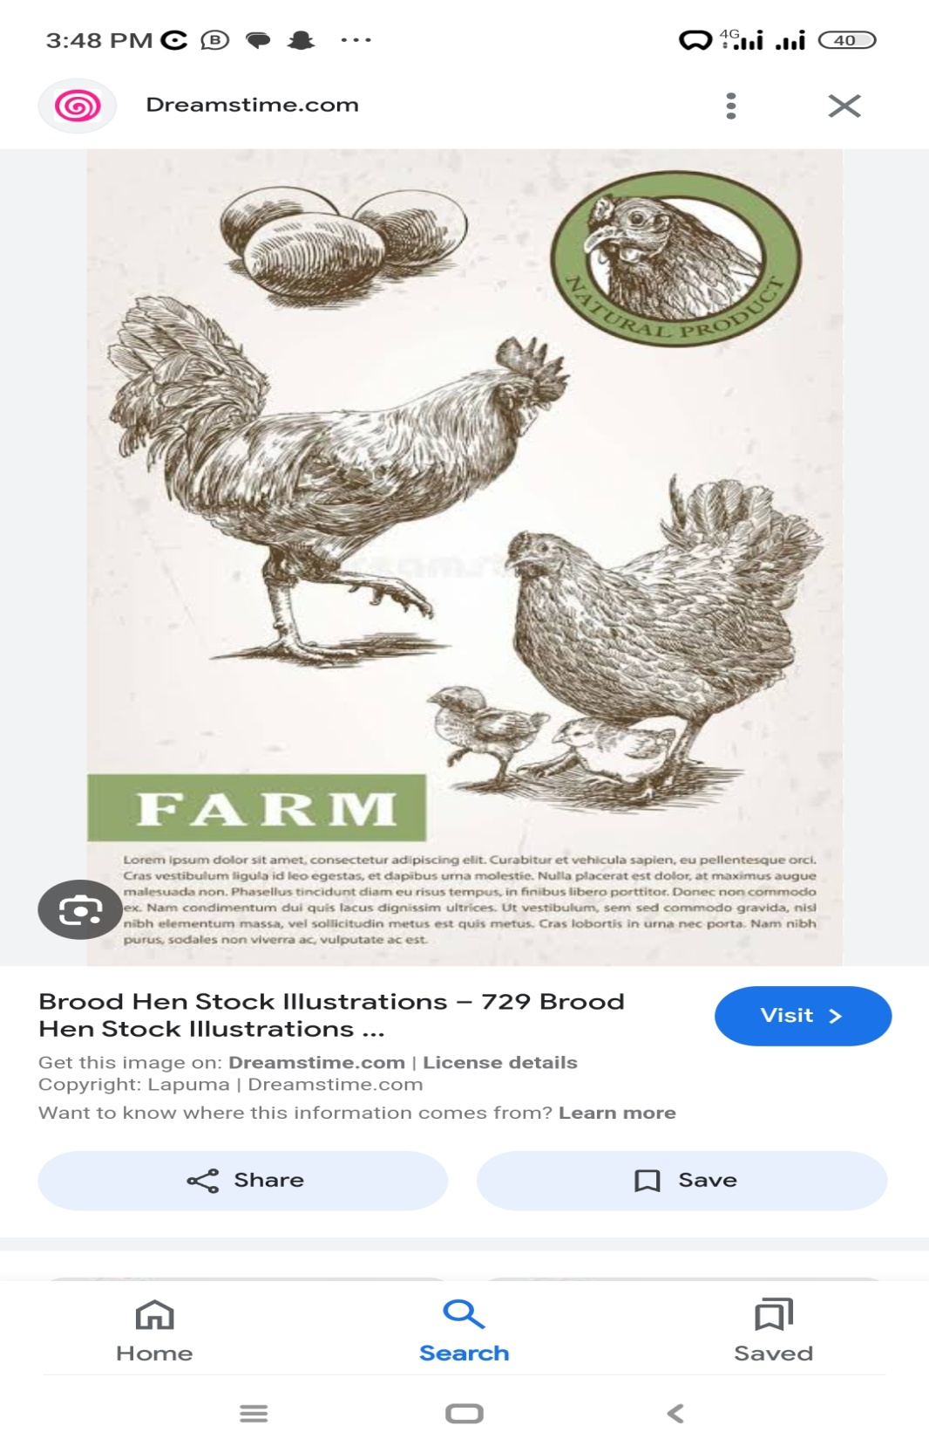

1. Name the type of brooding shown in the above diagram.

________________________________________________________________

1. State **one** disadvantage of using the brooding method you method mentioned in (28)

________________________________________________________________

1. Name **one** tick –borne disease that attack goats.

_______________________________________________________________

1. Name the blood vessel that carries oxygenated blood from the heart to all body parts.

________________________________________________________________

1. State **one** sign of poor sanitation at school.

_______________________________________________________________

1. Give **one** factor considered when selecting a breed of cattle.

_______________________________________________________________

1. Identify **one** exotic breed of pigs.

_______________________________________________________________

1. Which element of PHC is promoted when a P.6 boy feeds on a balanced diet?

________________________________________________________________

1. Why should calcium be added in the diet of a pregnant mother?

________________________________________________________________

1. How many teeth make a milk set of teeth?

________________________________________________________________

1. Identify **one** method of identifying cattle.

________________________________________________________________

1. Identify any **one** intestinal communicable disease that affect the digestive system.

_______________________________________________________________

1. What is meant by the term plant propagation?

________________________________________________________________________________________________________________________________

**SECTION B (60 MARKS)**

1. Below is a diagram of living house. Use it to answer questions that follow.



**Y**

**X**

1. State the function of the part labeled with letter X and Y.
2. X___________________
3. y ___________________
4. Why are ventilators placed above windows on a living house?

______________________________________________________________

1. By what process does heat from the sun help to dry harvested cereals.

______________________________________________________________

1. a) Briefly explain the term seed dispersal.

_______________________________________________________________________________________________________________________________

b) Which method of seed dispersal takes place in coconut seeds?

_______________________________________________________________

1. State any **two** importance of seed dispersal in the environment.
2. _________________________________________________________
3. _________________________________________________________
4. a) Which element of weather requires people to wear;
5. gumboots ___________________________________________________
6. light clothes _________________________________________________

b) Name the furthest clouds in the atmosphere.

______________________________________________________________

c) Why do farmers transplant their seedlings in the evening?

______________________________________________________________

1. 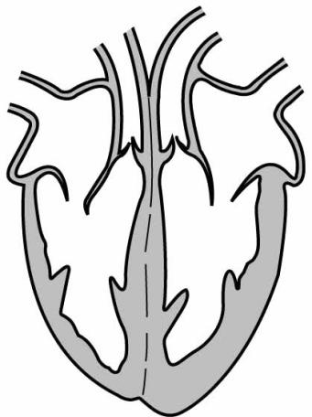**Below is a diagram of the human heart. Use it to answer questions that follow.**

**B**

**C**

**A**

**Septum**

1. Name the blood vessel marked with letter ;

A_____________________________ B_____________________________

1. Which type of blood is carried by the side of the heart marked with letter C?

_____________________________________________________________

1. State the function of the Septum muscle on the heart.

_____________________________________________________________

1. a) In which **one** way is transpiration similar to sweating?

_____________________________________________________________

b) State any **two** factors which affect the rate of transpiration.

i) ______________________________________________________________

ii) _____________________________________________________________

c) How is transpiration important to plants in the environment?

______________________________________________________________

1. a) What is meant by the following terms;
2. Drug abuse

______________________________________________________________________________________________________________________

1. Drug misuse

_______________________________________________________________________ _______________________________________________

b) State any **two** effects of drug abuse to an individual.

i)_____________________________________________________________

ii)_____________________________________________________________

1. a) Name the part used by a grasshopper for feeding.

________________________________________________________________

b) Where do grasshoppers lay their eggs?

_______________________________________________________________

1. Which type of lifecycle do grasshoppers undergo?

_______________________________________________________________

1. Give **one** importance of grasshoppers to people.

_______________________________________________________________

1. **Below is a diagram of a bean seed. Use it to answer questions that follow.**

**Y**

**P**

**Z**

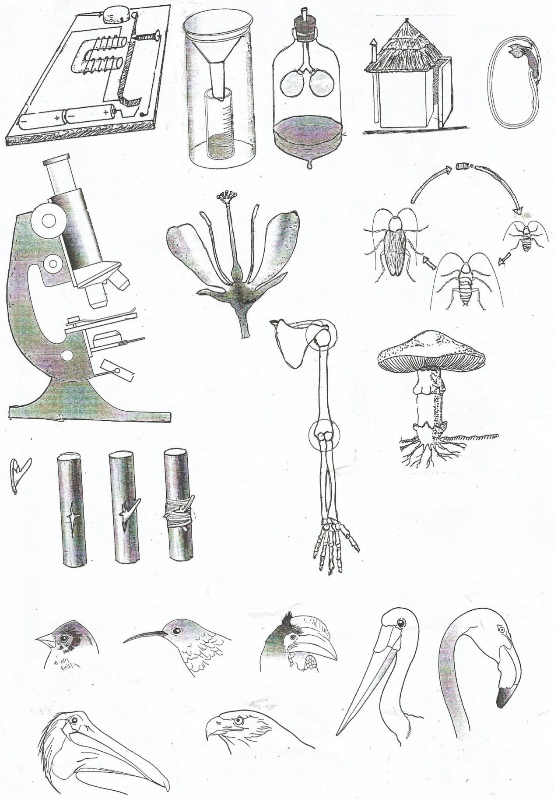

1. Name the part of a bean seed marked **Z.**

____________________________________________________________

1. State the function of part labeled with letter;
2. **P**______________________________________________________
3. **Y** ____________________________________________________
4. Which part of bean seed performs a similar function like an endosperm of maize grain?

_____________________________________________________________

1. What name is given to poison producing glands in snakes?

_____________________________________________________________

1. a) Apart from ferns, mention **two** other examples of spore bearing plants.

i)_____________________________ ii)______________________________

b) How do ferns reproduce?

________________________________________________________________

c) How are ferns different from conifers in terms of reproduction?

________________________________________________________________

1. a) In which way do the following reptiles protect themselves against enemies;
2. tortoise ____________________________________________________
3. Chameleon _________________________________________________

b) Name **one** example of a poisonous snake.

_______________________________________________________________

c) What name is given to poison producing glands in snakes?

________________________________________________________________

1. a) Give **two** reasons why farmers prefer keeping local breeds of cattle on farm to exotic breed.
2. ___________________________________________________________
3. ___________________________________________________________

b) Mention **two** dairy breeds of cattle kept in Uganda.

i) ____________________________ ii)______________________________

1. a) How are the following important to a deep litter house?
2. Perches ____________________________________________________
3. Litter ____________________________________________________

b) State any **two** advantages of using deep litter system of keeping poultry.

i) ______________________________________________________________

ii) _____________________________________________________________

1. Match the food values to their food deficiency.

**Food value Food deficiency**

1. Carbohydrates anaemia
2. Iodine marasmus
3. Iron kwashiorkor
4. proteins Goitre

**Correct order**

**Food value food deficiency**

1. Carbohydrates _____________________________________
2. Iodine _____________________________________
3. Iron _____________________________________
4. proteins _____________________________________
5. In which way are the following plants propagated.
6. Irish potatoes _________________________________________
7. Sugar cane _________________________________________

b) Identify **one** artificial method of vegetative plant propagation.

_____________________________________________________________

c) State **one** advantage of using vegetative plant propagation.

____________________________________________________________

1. a) What term refers to the softness or loudness of sound?

________________________________________________________________________________________________________________________________

b) How does a guitar produce sound?

______________________________________________________________

1. Why can’t sound travel through vacuum?

____________________________________________________________

1. In which state of matter does sound travel fastest?

_____________________________________________________________

*END*

*BY TEACHER HAMUSON*

*0784-904957 (ATLAS JUNIOR SCIENCE DEPARTMENT)*